Hospital Icon Design and User Experience Survey 2
Introduction
Hello! We are students from Jiangnan University. We are conducting a survey on hospital icon design for design research purposes. This survey will be conducted strictly according to the requirements; no name is required, and there are no right or wrong answers. The survey results will only be used for data analysis. Your response is crucial to our research, so please be sure to complete the questionnaire truthfully. Thank you for your support and cooperation.
November 2023
1. What is your age? *
○ 18–25 years old
○ 26–35 years old
○ 36–45 years old
○ 46–55 years old
○ 56 years old or above
2. What is your gender? *
○ Male
○ Female
3. What is your monthly income level? *
○ Less than 5,000 MOP / month
○ 5,000 – 9,999 MOP / month
○ 10,000 – 19,999 MOP / month
○ 20,000 – 49,999 MOP / month
○ 50,000 MOP / month or above
4. What is your highest level of education? *
○ Primary school or below
○ Junior high school
○ High school / technical secondary school / vocational school
○ Bachelor’s degree
○ Master’s degree or above
5. What is your occupation? *
○ Doctor / medical staff
○ Student / teacher / educator
○ Technician / manager
○ Designer / artist
○ Other: _________________________
6. In the pediatric clinic, which type of icon do you prefer to use? *
○ Static icon
○ Dynamic icon
7. In the pediatric clinic, which style of the selected icon type do you prefer? *
[Single choice]

○ Linear icon

○ Filled (planar) icon
Conditional: This question is only shown if you selected “Static icon” in Question 6
8. In the pediatric clinic, which style of the selected icon type do you prefer? *
[Single choice]

○ Linear icon

○ Filled (planar) icon
Conditional: This question is only shown if you selected “Dynamic icon” in Question 6
9. How do you think the selected icon affects emotional relief in the pediatric clinic? *
[Single choice]

1 Very harmful to emotional relief 2 3 Neutral 4 5 Very beneficial to emotional relief
Conditional: This question is shown for both “Static icon” and “Dynamic icon” selections in Question 6
10. How do you think the selected icon affects the efficiency of medical treatment in the pediatric clinic? *
[Single choice]

1 No impact at all 2 3 Neutral 4 5 Very significant impact
Conditional: This question is shown for both “Static icon” and “Dynamic icon” selections in Question 6
11. In the emergency department, which type of icon do you prefer to use? *
[Single choice]
○ Static icon
○ Dynamic icon
12. In the emergency department, which style of the selected icon type do you prefer? *
[Single choice]
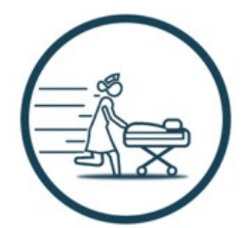
○ Linear icon

○ Filled (planar) icon
12. (Continued from Question 11)
In the emergency department, which style of the selected icon type do you prefer? *
[Single choice]
○ Linear icon
○ Filled (planar) icon
Conditional: This question is shown for both “Static icon” and “Dynamic icon” selections in Question 11
13. In the emergency department, which style of the selected icon type do you prefer? *
[Single choice]

○ Linear icon

○ Filled (planar) icon
Conditional: This question is only shown if you selected “Dynamic icon” in Question 11
14. How do you think the selected icon affects emotional relief in the emergency department? *
[Single choice]
1 Very harmful to emotional relief 2 3 Neutral 4 5 Very beneficial to emotional relief
Conditional: This question is shown for both “Static icon” and “Dynamic icon” selections in Question 11
15. How do you think the selected icon affects the efficiency of medical treatment in the emergency department? *
[Single choice]
表格
1 No impact at all 2 3 Neutral 4 5 Very significant impact
Conditional: This question is shown for both “Static icon” and “Dynamic icon” selections in Question 11
16. In the dental clinic, which type of icon do you prefer to use? *
[Single choice]
○ Static icon
○ Dynamic icon
17. In the dental clinic, which style of the selected icon type do you prefer? *
[Single choice]
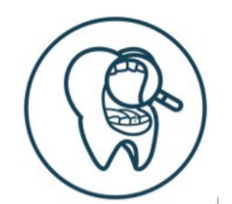
○ Linear icon
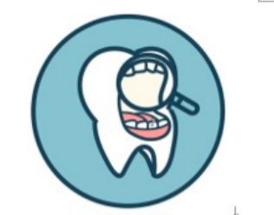
○ Filled (planar) icon
17. (Continued from Question 16)
In the dental clinic, which style of the selected icon type do you prefer? *
[Single choice]
○ Linear icon
○ Filled (planar) icon
Conditional: This question is shown for both “Static icon” and “Dynamic icon” selections in Question 16
18. In the dental clinic, which style of the selected icon type do you prefer? *
[Single choice]

○ Linear icon


○ Filled (planar) icon
Conditional: This question is only shown if you selected “Dynamic icon” in Question 16
19. How do you think the selected icon affects emotional relief in the dental clinic? *
[Single choice]
1 Very harmful to emotional relief 2 3 Neutral 4 5 Very beneficial to emotional relief
Conditional: This question is shown for both “Static icon” and “Dynamic icon” selections in Question 16
20. How do you think the selected icon affects the efficiency of medical treatment in the dental clinic? *
[Single choice]

1 No impact at all 2 3 Neutral 4 5 Very significant impact
Conditional: This question is shown for both “Static icon” and “Dynamic icon” selections in Question 16
21. In the orthopedic clinic, which type of icon do you prefer to use? *
[Single choice]
○ Static icon
○ Dynamic icon
22. In the orthopedic clinic, which style of the selected icon type do you prefer? *
[Single choice]

○ Linear icon
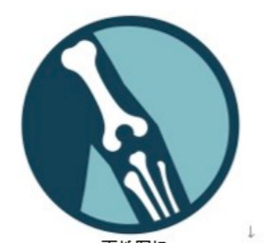
○ Filled (planar) icon
22. (Continued from Question 21)
In the orthopedic clinic, which style of the selected icon type do you prefer? *
[Single choice]
○ Linear icon
○ Filled (planar) icon
Conditional: This question is shown for both “Static icon” and “Dynamic icon” selections in Question 21
23. In the orthopedic clinic, which style of the selected icon type do you prefer? *
[Single choice]

○ Linear icon

○ Filled (planar) icon
Conditional: This question is only shown if you selected “Dynamic icon” in Question 21
24. How do you think the selected icon affects emotional relief in the orthopedic clinic? *
[Single choice]
表格
1 Very harmful to emotional relief 2 3 Neutral 4 5 Very beneficial to emotional relief
Conditional: This question is shown for both “Static icon” and “Dynamic icon” selections in Question 21
25. How do you think the selected icon affects the efficiency of medical treatment in the orthopedic clinic? *
[Single choice]
1 No impact at all 2 3 Neutral 4 5 Very significant impact
Conditional: This question is shown for both “Static icon” and “Dynamic icon” selections in Question 21
26. Do you think all the icons you just selected can effectively attract your attention? *
[Single choice]

1 Not at all 2 3 Neutral 4 5 Completely effective
27. Do you think all the icons you just selected help you find your way faster? *
[Single choice]

1 Not at all 2 3 Neutral 4 5 Completely effective
28. Do you think all the icons you just selected are effective in navigation and information delivery? *
[Single choice]
（：1 = Completely ineffective 到 5 = Extremely effective）
28. Do you think all the icons you just selected are effective in navigation and information delivery? *
[Single choice]

1 Completely ineffective 2 3 Neutral 4 5 Extremely effective
29. Do you think all the icons you just selected are easy to understand? *
[Single choice]

1 Completely difficult to understand 2 3 Neutral 4 5 Extremely easy to understand
30. Do you think all the icons you just selected are useful for conveying hospital-related information? *
[Single choice]

1 Completely useless 2 3 Neutral 4 5 Extremely useful

